## **Omnichannel Contact Center Solution.**

Integrated Customer Communication: Omnichannel Contact Center Solution

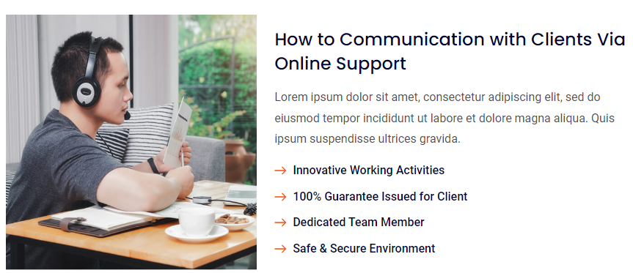

[**What iHelpBD offers:**](https://www.ihelpbd.com/)

With an omnichannel contact center solution, iHelp enables customers to communicate through multiple channels, allowing them to choose and switch seamlessly between options wherever they feel most comfortable Facebook messenger

* Whatsapp
* E-mail
* SMS
* Voice chat
* Webchat

**iHelP offers the solution**

To prevent losing business, an advanced omnichannel contact center solution is essential. By integrating channels like voice chat, email, and CRM, it ensures a smooth customer journey, which iHelpBD prioritizes with its developed solution that consolidates communication on a single platform.

This solution allows agents to access a customer's complete interaction history, enabling personalized service. Customers can communicate through their preferred channels, enhancing their overall experience.

iHelpKL's omnichannel contact center streamlines operations, helping businesses meet customer expectations and improve satisfaction, ultimately fostering loyalty and maintaining competitiveness in the market.

**Benefits**

* The main goal of an omnichannel contact center is to enhance customer experience.
* Customers can easily switch to text to send images without repeating their issue.
* Agents can access prior interactions via CRM, ensuring consistent service.
* Customers can choose from channels like Facebook Messenger, WhatsApp, email, or web chat, preventing lost opportunities.
* iHelpKL is committed to providing a seamless customer journey through its omnichannel solution on a single platform.

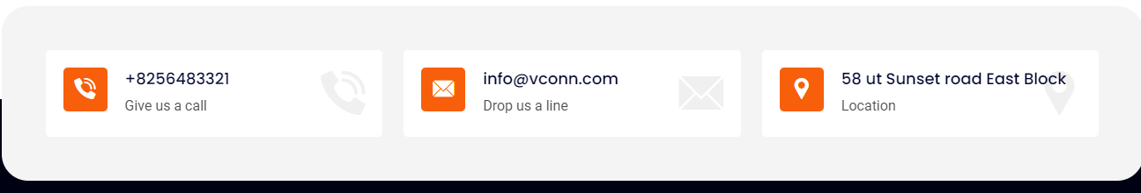

**Reference** 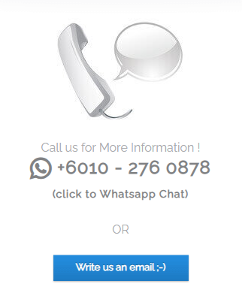

**We will add later**

